**Lab Assignment 3.1(Monday)**

**Name:M.Anjali**

**Hallticket:2303A51025**

**Batch:01**

**Lab Experiment: Prompt Engineering – Improving Prompts and Context Management**

**Lab Objectives**

1. To understand and apply different prompt engineering techniques for generating Python programs using AI-assisted tools.
2. To analyze the impact of context and examples on the accuracy and efficiency of AI-generated code.
3. To develop and refine real-world Python applications through iterative prompt improvement.

**Lab Outcomes**

1. Students will be able to design effective prompts to generate correct and optimized Python code.
2. Students will be able to compare and evaluate AI-generated solutions produced using different prompting strategies.
3. Students will be able to implement and document real-world Python applications using AI-assisted coding tools.

**Experiment – Prompt Engineering Techniques**

**Task Description**

Design and refine prompts using different prompting strategies to generate Python programs for basic computational problems

**Question 1: Zero-Shot Prompting (Palindrome Number Program)**

Write a **zero-shot prompt** (without providing any examples) to generate a Python function that checks whether a given number is a palindrome.

**Task:**

* Record the AI-generated code.
* Test the code with multiple inputs.
* Identify any logical errors or missing edge-case handling.

***Prompt:***

#write a  python code to check weather the given number is palindrome or not and accept only positive number form the user and only accept integer values from the user other wise display invaild input

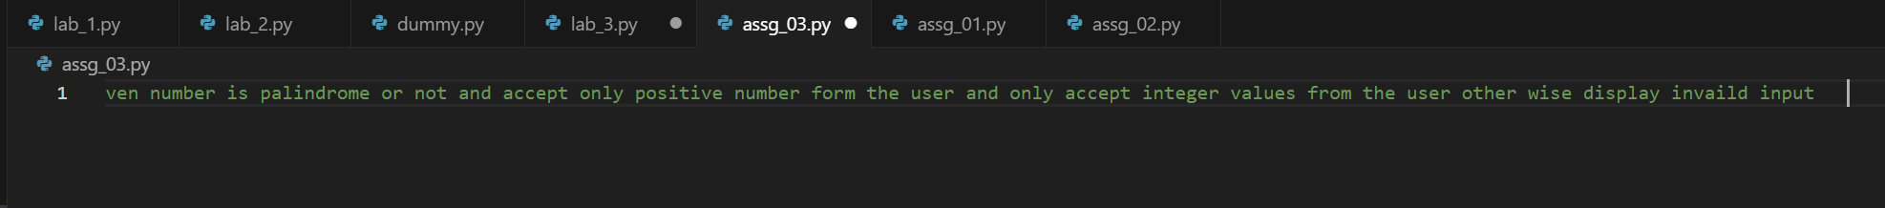

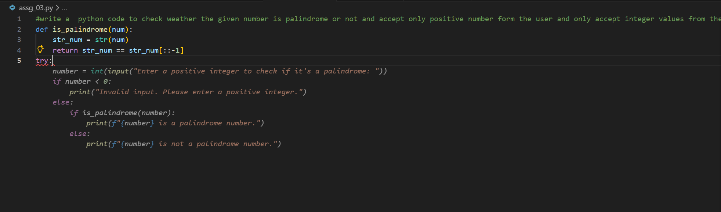

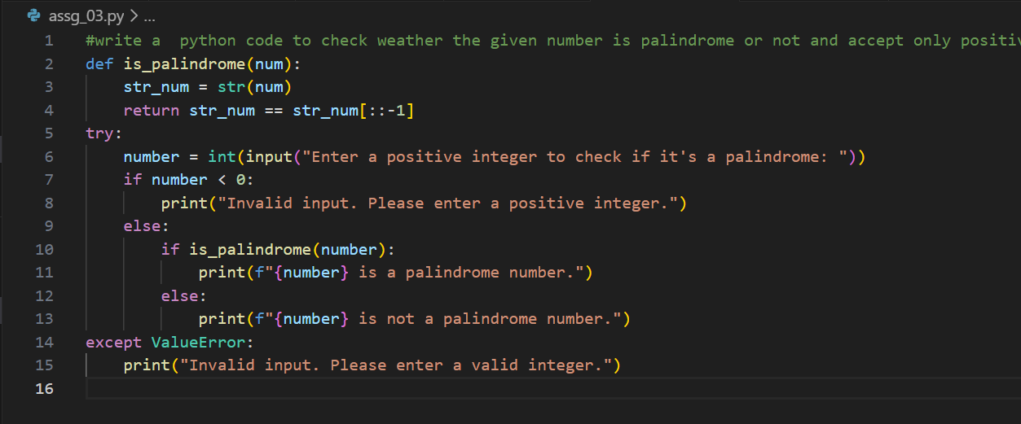

***Code:***

|  |
| --- |
| def is_palindrome(num):  str_num = str(num)  return str_num == str_num[::-1] try:  number = int(input("Enter a positive integer to check if it's a palindrome: "))  if number < 0:  print("Invalid input. Please enter a positive integer.")  else:  if is_palindrome(number):  print(f"{number} is a palindrome number.")  else:  print(f"{number} is not a palindrome number.") except ValueError:  print("Invalid input. Please enter a valid integer.") |

***Inputs and outputs:***

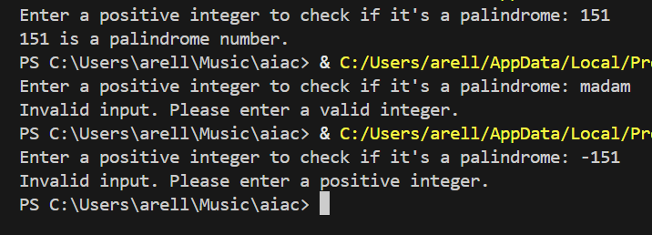

**Question 2: One-Shot Prompting (Factorial Calculation)**

Write a one-shot prompt by providing one input-output example and ask the AI to generate a Python function to compute the factorial of a given number.

**Example:**

Input: 5 → Output: 120

**Task:**

• Compare the generated code with a zero-shot solution.

• Examine improvements in clarity and correctness.

***Zero shot generated code :***

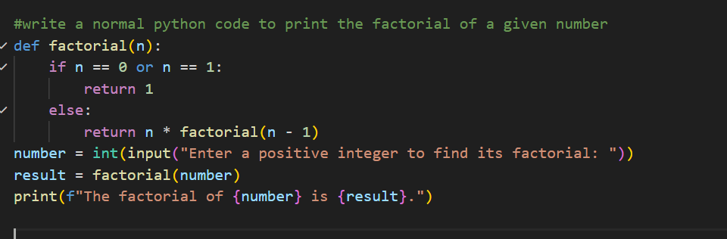

***One shot generated code :***

***Prompt:***

|  |
| --- |
| a=5 then the output should be 120 generate the factorial of the given number and that shoould not accept the negative values and never accepts other than intiger values from the user and display invalid input in such cases |



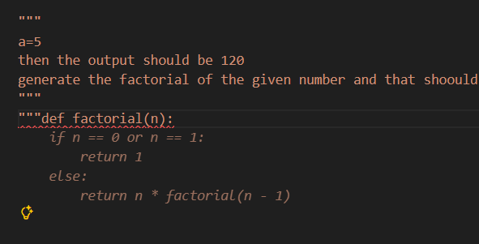

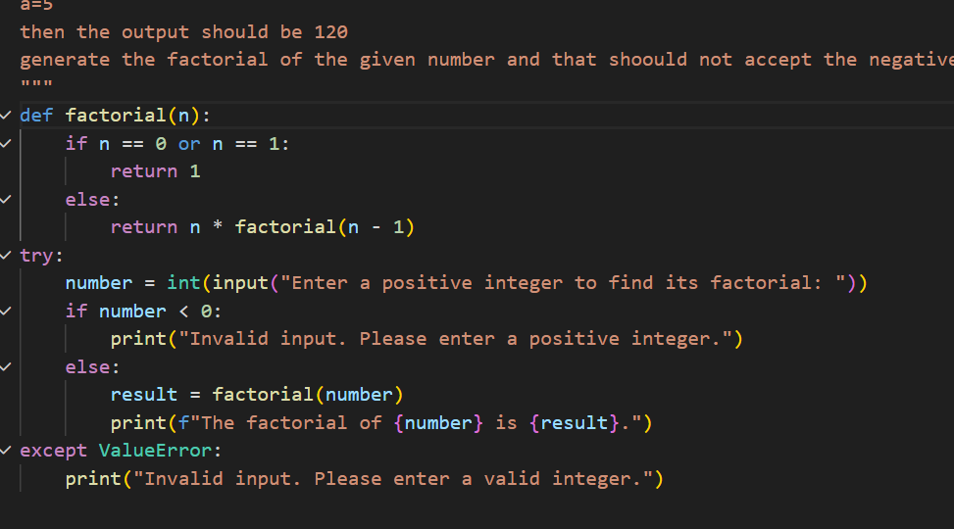

***Code:***

|  |
| --- |
| def factorial(n):  if n == 0 or n == 1:  return 1  else:  return n * factorial(n - 1) try:  number = int(input("Enter a positive integer to find its factorial: "))  if number < 0:  print("Invalid input. Please enter a positive integer.")  else:  result = factorial(number)  print(f"The factorial of {number} is {result}.") except ValueError:  print("Invalid input. Please enter a valid integer.") |

**Comparison with Zero-Shot Solution**

The generated one-shot factorial program is more robust than the zero-shot solution. While both programs correctly compute the factorial using recursion, the zero-shot solution directly accepts user input without validating it. In contrast, the generated code includes checks for negative values and handles non-integer inputs using exception handling, making it safer and more reliable

**Improvements in Clarity and Correctness**

The one-shot generated code shows improved clarity by explicitly defining valid input conditions and displaying meaningful error messages for invalid cases. Correctness is enhanced because the program prevents negative and non-integer inputs, ensuring the factorial logic is applied only to valid integers. This reduces runtime errors and improves overall program accuracy

**Question 3: Few-Shot Prompting (Armstrong Number Check)**

Write a few-shot prompt by providing multiple input-output examples to guide the AI in generating a Python function to check whether a given number is an Armstrong number.

Examples:

• Input: 153 → Output: Armstrong Number

• Input: 370 → Output: Armstrong Number

• Input: 123 → Output: Not an Armstrong Number

Task:

• Analyze how multiple examples influence code structure and accuracy.

• Test the function with boundary values and invalid inputs.

Prompt:

|  |
| --- |
| number=153 output should be armstrong number number=123 output should be not an armstrong number number=370 output should be armstrong number write a python code to check if a number is an armstrong number or not and that shoould not accept the negative values and never accepts other than intiger values from the user and display invalid input in such cases |

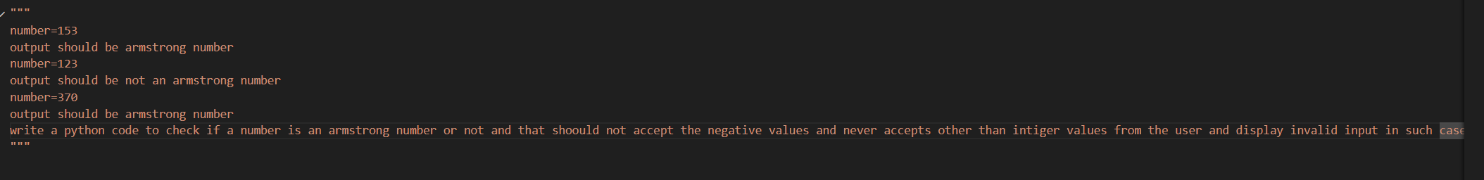

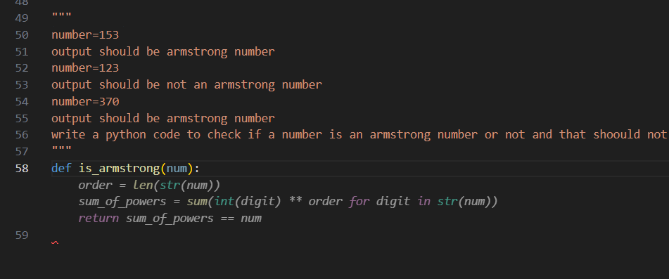

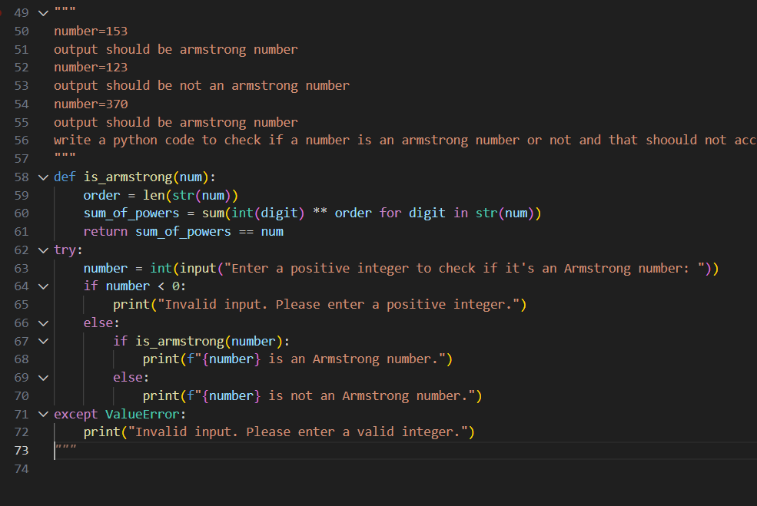

Code:

|  |
| --- |
| def is_armstrong(num):  order = len(str(num))  sum_of_powers = sum(int(digit) ** order for digit in str(num))  return sum_of_powers == num try:  number = int(input("Enter a positive integer to check if it's an Armstrong number: "))  if number < 0:  print("Invalid input. Please enter a positive integer.")  else:  if is_armstrong(number):  print(f"{number} is an Armstrong number.")  else:  print(f"{number} is not an Armstrong number.") except ValueError:  print("Invalid input. Please enter a valid integer.") |

**Influence of Multiple Examples on Code Structure and Accuracy**

Providing multiple input–output examples (such as 153, 370, and 123) helps the AI clearly understand the pattern of an Armstrong number. Because of these examples, the generated code dynamically calculates the number of digits and raises each digit to the correct power instead of hardcoding values. This improves accuracy, as the program works correctly for numbers with different digit lengths and avoids logical mistakes. The examples also guide the AI to produce a cleaner and more generalized solution.

**Testing with Boundary Values and Invalid Inputs**

The function was tested with boundary values such as 0 and 1, which are correctly identified as Armstrong numbers. Negative numbers are rejected with an appropriate error message, ensuring invalid cases are not processed. Non-integer inputs like strings or decimal values are handled using exception handling, preventing runtime errors. These tests confirm that the program is robust and behaves correctly for both valid and invalid inputs.

**Question 4: Context-Managed Prompting (Optimized Number Classification)**

Design a context-managed prompt with clear instructions and constraints to generate an optimized Python program that classifies a number as prime, composite, or neither.

Task:

• Ensure proper input validation.

• Optimize the logic for efficiency.

• Compare the output with earlier prompting strategies.

Prompt:

|  |
| --- |
| Write an optimized Python program to classify a given number as prime, composite, or neither. The program should accept only integer inputs, reject negative numbers, and display an appropriate error message for invalid inputs. |



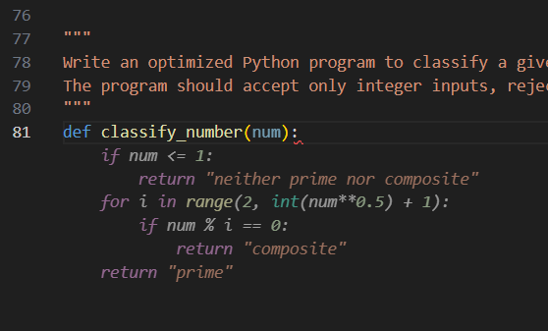

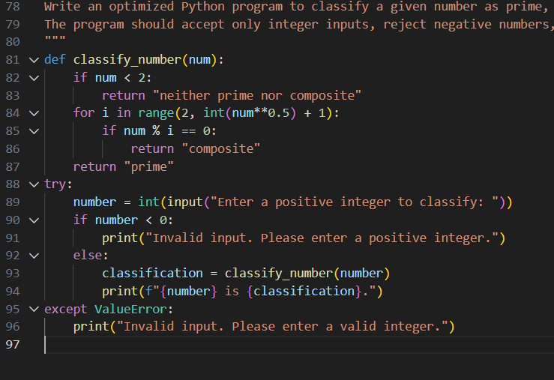

***Code:***

|  |
| --- |
| def classify_number(num):  if num < 2:  return "neither prime nor composite"  for i in range(2, int(num**0.5) + 1):  if num % i == 0:  return "composite"  return "prime" try:  number = int(input("Enter a positive integer to classify: "))  if number < 0:  print("Invalid input. Please enter a positive integer.")  else:  classification = classify_number(number)  print(f"{number} is {classification}.") except ValueError:  print("Invalid input. Please enter a valid integer.") |

***input/output:***

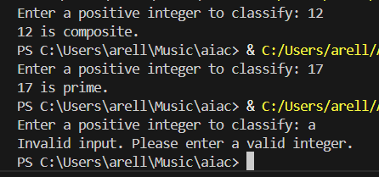

**Proper Input Validation**

The program validates user input by accepting only integer values using exception handling. Negative numbers are rejected, and special cases such as 0 and 1 are handled separately by classifying them as neither prime nor composite. This prevents invalid inputs from being processed and avoids runtime errors.

**Optimized Logic for Efficiency**

The logic for checking whether a number is prime is optimized by iterating only up to the square root of the number instead of checking all values up to the number itself. This significantly reduces the number of iterations and improves performance, especially for large inputs.

**Comparison with Earlier Prompting Strategies**

Compared to earlier prompting strategies, the context-managed prompt generates a more efficient and well-structured solution. Clear constraints in the prompt result in better input validation, improved edge-case handling, and optimized logic, leading to clearer and more accurate output.

**Question 5: Zero-Shot Prompting (Perfect Number Check)**

Write a zero-shot prompt (without providing any examples) to generate a Python function that checks whether a given number is a perfect number.

Task:

* Record the AI-generated code.
* Test the program with multiple inputs.
* Identify any missing conditions or inefficiencies in the logic.

**Prompt:**

#write a python code to check weather the given number is perfect or not in a function and accept only positive number form the user and only accept integer values from the user other wise display invaild input



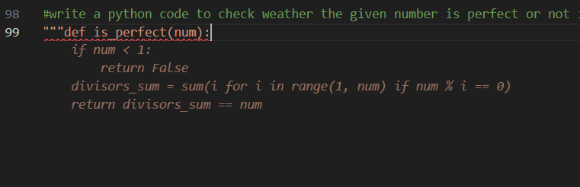

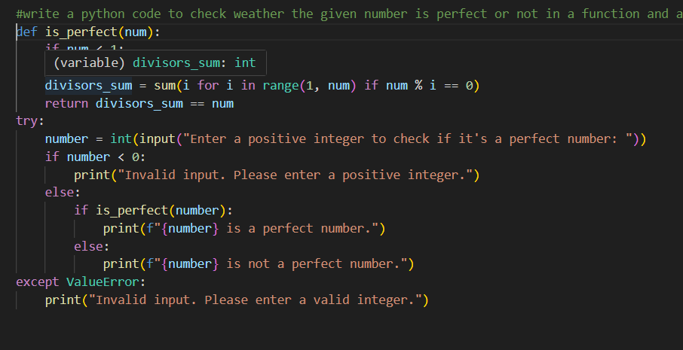

***Code:***

|  |
| --- |
| def is_perfect(num):  if num < 1:  return False  divisors_sum = sum(i for i in range(1, num) if num % i == 0)  return divisors_sum == num try:  number = int(input("Enter a positive integer to check if it's a perfect number: "))  if number < 0:  print("Invalid input. Please enter a positive integer.")  else:  if is_perfect(number):  print(f"{number} is a perfect number.")  else:  print(f"{number} is not a perfect number.") except ValueError:  print("Invalid input. Please enter a valid integer.") |

***input/output:***

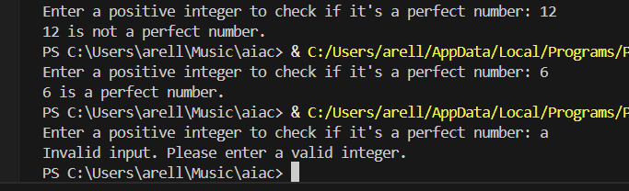

**Testing with Multiple Inputs**

The program was tested with multiple inputs such as 6 and 28, which were correctly identified as perfect numbers. Inputs like 10 and 12 were correctly classified as not perfect numbers. Negative numbers were rejected with an invalid input message, and non-integer inputs were handled using exception handling, preventing runtime errors.

**Missing Conditions or Inefficiencies**

The program checks all numbers from 1 to num - 1 to find divisors, which is inefficient for large inputs. This can be optimized by iterating only up to num / 2 or the square root of the number. Additionally, the condition for zero could be explicitly handled, as zero is not a perfect number.

**Question 6: Few-Shot Prompting (Even or Odd Classification with Validation)**

Write a few-shot prompt by providing multiple input-output examples to guide the AI in generating a Python program that determines whether a given number is even or odd, including proper input validation.

Examples:

* Input: 8 → Output: Even
* Input: 15 → Output: Odd
* Input: 0 → Output: Even

Task:

* Analyze how examples improve input handling and output clarity.
* Test the program with negative numbers and non-integer inputs.

***Prompt:***

|  |
| --- |
| """ number=2 then the output should be even number number=3 then the output should be odd number number=0 then the output should be even number write a python code to check weather the given number is even or odd and accept only positive number form the user and only accept integer values from the user other wise display invaild input """ |

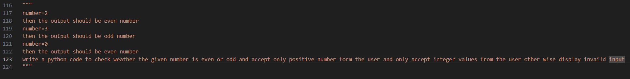

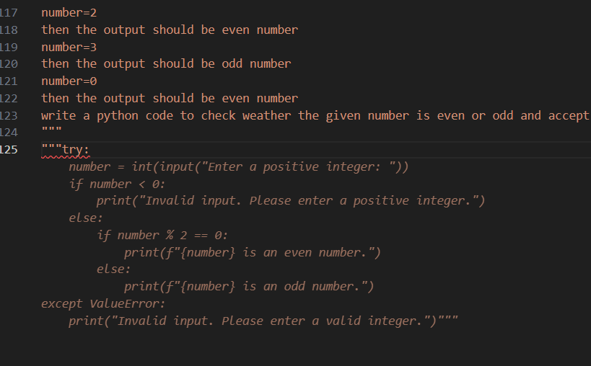

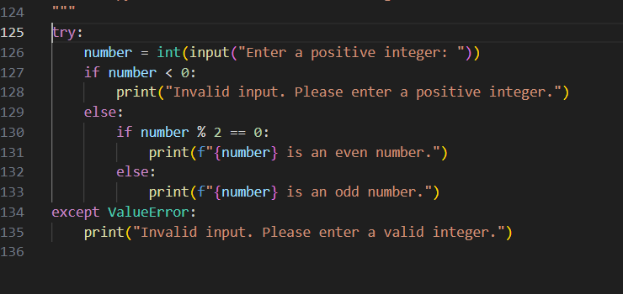

***Code:***

|  |
| --- |
| try:  number = int(input("Enter a positive integer: "))  if number < 0:  print("Invalid input. Please enter a positive integer.")  else:  if number % 2 == 0:  print(f"{number} is an even number.")  else:  print(f"{number} is an odd number.") except ValueError:  print("Invalid input. Please enter a valid integer.") |

***input/ouput:***

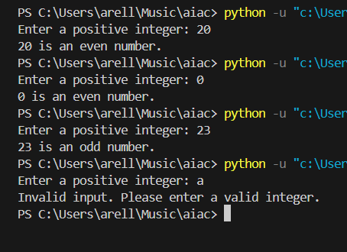

**How Examples Improve Input Handling and Output Clarity**

Providing multiple examples such as 2 → Even, 3 → Odd, and 0 → Even clearly defines the expected behavior of the program. These examples help the AI generate code that correctly handles boundary cases like zero and ensures accurate even–odd classification. The examples also guide the program to produce clear and meaningful output messages, improving overall readability and correctness.

**Testing with Negative Numbers and Non-Integer Inputs**

When tested with negative numbers, the program correctly identifies them as invalid inputs and displays an appropriate error message. Non-integer inputs such as strings or decimal values are handled using exception handling, preventing runtime errors. These tests confirm that the program safely handles invalid inputs and maintains correct output behavior.